**Experiment 3: - Introduction to Amazon DynamoDB**

**In this lab, you will learn how to:**

* Create a DynamoDB table.
* Enter data into a DynamoDB table.
* Query a DynamoDB table.
* Delete a DynamoDB table.

**Introduction to AWS Educate:**

AWS Educate is an online platform built by Amazon that enables users to learn AWS by providing access to online training resources and labs to learn, practice, and evaluate cloud skills without having to create an Amazon or AWS account. In this course, we will be working with AWS Educate, which familiarizes you with AWS.

**Setting up an AWS Educate account and Accessing the Lab:**

1. Click here to go to [AWS Educate](https://aws.amazon.com/education/awseducate/).
2. Click on “Register Now”
3. Provide your **SRN** as the First Name and your **name** as the last name while filling the required details to register.
4. Verify the given email address to complete the registration.
5. Set a password for the AWS Educate account.
6. Login into your account and choose the course **“Introduction to Cloud 101.”**
7. Under modules choose the module “[Lab 3 - Introduction to](https://awseducate.instructure.com/courses/746/modules/items/13185) Amazon DynamoDB”.
8. Explore the course!

**What is Amazon DynamoDB?**

Amazon DynamoDB is a fully managed NoSQL database service that provides fast and predictable performance with seamless scalability. DynamoDB lets you offload the administrative burdens of operating and scaling a distributed database so that you don't have to worry about hardware provisioning, setup and configuration, replication, software patching, or cluster scaling. DynamoDB also offers encryption at rest, which eliminates the operational burden and complexity involved in protecting sensitive data.

<https://aws.amazon.com/dynamodb/>

[DynamoDB documentation](https://docs.aws.amazon.com/amazondynamodb/latest/developerguide/Introduction.html)

**Deliverables:**

**Note: Submit only the screenshots mentioned below**

The following screenshots are to be submitted:

* Screenshot 1a: Creation of table (1 mark)
* Screenshot 2a: Show the inserted entries in table **(Make sure the Items returned table is expanded such that all fields are shown and the name of the Table is also visible to the left)** (2 marks)
* Screenshot 3a: Show the entries post update **(Make sure the Items returned table is expanded such that all fields are shown and the name of the Table is also visible to the left)** (2 marks)
* Screenshot 4a: Result of the query Artist (Partition key): Psy, Song (Sort key): Equal to Gangnam Style **(Make sure both the query parameters filled are visible along with the result of the query)** (2 marks)
* Screenshot 4b: Result of Scan filter **(Make sure the ‘Scan’ radio button selection, Attribute name and the result are present in the screenshot)** (2 marks)
* Screenshot 5a: Data after deletion of an item from the table (1 mark)

**NOTE : Make sure the account name(containing SRN) on the top right is visible in ALL the screenshots submitted (Shown in the below screenshot)**

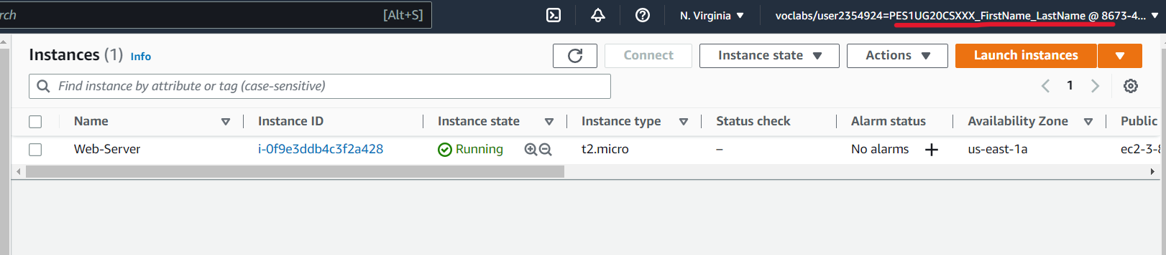

**NOTE:** The screenshots must be pasted into a Word document and sent in PDF format. The file should be named in this manner **<Section>_<SRN>_<Name>_E3.pdf** (E.g. A_PES1UG20CSXXX_Name_E3.pdf)

**Points to note:**

1. AWS Educate will create a temporary AWS account with all the required permissions and access to complete the lab. **Do not** use your personal AWS account. To prevent conflicts with any AWS account that you have already signed into on your browser, use incognito mode.

2. **DO NOT** change the default region/ VPC or any other settings that are automatically created by AWS Educate.

3. The AWS Educate lab session is timed. When the time limit is reached/the timer expires, the AWS account is deleted, and you must restart the lab from the beginning.

4. All code and configuration for the AWS Educate lab have already been given. You are not required to code anything from scratch or deviate from this for the lab experiments. However, in some cases, you may be required to name the resources you use differently, as instructed.

5. The assignments may require you to deviate from the AWS Educate instructions and use your own code. Instructions will be given.

6. **DO NOT** try to access or avail any other resources and services that have not been described in the lab session or your account will be blocked.

7. Ensure that you have signed into AWS Educate from your mail account.